ALAMEDA COUNTY
BEHAVIORAL HEALTH CARE SERVICES (ACBH)

Frequently Asked Questions:
Smartcare Service Entry TRAINING

Alameda County Behavioral Health Care Services

As of March 11, 2024
- When will Smart Care (SC) service entry functions become available, so providers can enter their services into the system?
Service Entry Go-Live will begin March 12th for MHS and for OTP/CG Users March 19th.

- Will the training be On-Site or Virtual?

We will be offering both In-Person and Virtual training to support all learning styles. You must be registered to participate.

- How can I register for training?

You can register for training on the Provider’s website in the SmartCare section.

- Are there prerequisite trainings that I need to take prior to Service Entry training?

Yes, if you do not have any exposure to SmartCare, please watch the SmartCare Basic Navigation Training. Also, make sure you’ve completed Client Registration and Program Enrollment training. You may take a course refresher by reviewing Training Recordings.

- Will there be a Service Entry training manual?

Yes, the Service Entry training Mini-Manual will be posted on the website, in addition to the MHS SC Mini Manual and SUD CalOMS Mini-Manual.

- Will there be Service Entry recordings?

Yes, these will be derived from the training sessions and will be posted on the website under Current Recordings.

- What functions will be included in the Service Entry Go-Live?
Go-live will Include:

- Single Service Entry Screen
- Batch Service Entry Screen
- Transfer of CG Services to SmartCare will be announced shortly after the Go-Live.

- How can I prepare for Service Entry Go-Live?
To prepare for Service Entry you will need to complete the below tasks as follows:

- Check to ensure that clients are enrolled in the correct program, by reviewing the SmartCare “Programs Assignment” screen.
- Review “Clients (Documents)” screen to ensure that the client has a Diagnosis Document. The diagnosis must be checked as “Primary,” have a sort order of “1”, and have a document “Effective Date” within the Service period.
- Ensure clinical and non-clinical staff have accurate data in SmartCare. All staff must have the correct Programs, Roles, and Clinical Data Access Group (CDAG) security assigned to their staff record in order to Complete program Enrollment and Service Entry.
- Clinical staff, including unlicensed staff and MHS Graduate Students, must have the correct License/Degree (Discipline) as defined by DHCS and ACBH QA, to select the allowed procedure codes.

- How do I submit staff changes in Smart Care (SC)?
Submit a staff e-form for all new, expired, or to update clinical or non-clinical staff information. Please review the applicable links:
- MHS -- SmartCare Staff ID Number Request Form (MHS)
- SUD -- SmartCare Staff ID Number Request Form (SUD)

- How do I submit staff changes for a staff that requires a SC login?
For staff that require a SC login you must complete a SmartCare Staff Authorization Form. Staff who also require a (Clinician Gateway) CG login must complete both a SmartCare Staff ID Number Request and Staff Authorization form.
- How do I submit staff changes for a staff that requires a CG login?

For staff that require a CG login, the following forms must be completed in the order as follows:
- SmartCare Staff ID Number Request Form MHS or SUD
- SmartCare Staff Authorization Form
- CG Staff Authorization Request

- Who do I contact if a client is enrolled in an incorrect program or if there are issues with staff accounts?

Please contact the Help Desk (HIS@acgov.org or HCSASupport@acgov.org) for resolution prior to Service Entry.

- How do I review changes to SUD Program types in SC?

Please visit the following link: Changes to SUD Program Types in SmartCare

- How do I review the CPT Procedure Code changes from InSyst to SmartCare?
A crosswalk has been created to demonstrate what CPT Procedure Codes you should be using. Please visit the following links:
- MH SmartCare Procedure Code Table Eff 7-1-2023 - Updated 10/4/23.
- SUD SmartCare Procedure Codes Table Eff. 7-1-2023 - Updated 8/2/23.

- Where can I go for SC updates, Training dates, Office Hours and links, key forms, manuals, and training videos?

Please visit the following link: ACBH Providers Website - SmartCare (acgov.org)

- Where can I go to view additional SmartCare (SC) information?

Please visit the following link: SmartCare and Payment Reform Quick Reference Memo

- Where can the DHCS Billing Manuals be found online?

Please visit the following link: MedCCC - Library (ca.gov)

- What happens if the service is over the max time billable? does that mean the whole service is invalid to be billed?

If the user tries to enter a service for more than the max time billable for the primary code and any applicable add-on time the system will not allow that entry. The SmartCare system is set up to align with Medi-Cal billing rules and regulations. Per the DHCS Billing Manuals.

- How do I manually enter an add-on code to prolong a service in SmartCare using procedure Code G2212?

Reference the MH SmartCare Procedure Code Table Eff 7-1-2023

Example:

If 60 minutes of procedure code 90791 (Psychiatric diagnostic evaluation, 15 minutes) service time was provided:

60 minutes of service time - 15 minutes base time for the primary procedure code 90791= 45 minutes for the G2212 add-on code

SmartCare (SC) Service entry:

- Via the SC service detail screen, enter 15 minutes (base time) duration on the 90791primary procedure code.
- Click on the Add-on tab to select the G2212 add-on code from the drop-down list.
- SC will automatically display the Start time and duration from the 90791 primary code. Leave the start time as displayed and change the duration to the remaining 45 minutes for the service.
- Once all of your service data has been entered, click on the Save button.
- The service will go through a nightly completion process and will create a service for (1) unit or 15 minutes for CPT 90791 code and create a separate service for (3) units or 45 minutes for CPT G2212 code. Both services will be linked together when claiming.

- How do we enter the time in for group services in SmartCare?
Claims should be entered separately for each beneficiary receiving group therapy per below:
- Enter total face to face time on each beneficiary claim.
- Enter total travel time for the service on one of the client service records OR divide evenly between each group participant.
- Enter individual documentation time for each client separately on each participant’s service.
Example:
A group with 5 participants meets for 90 minutes. The clinician travelled 60 minutes round trip and spent 15 minutes documenting each beneficiary’s note. The screens would be completed as follows:
Option 1:
Face-to-Face/Total Duration: 90 minutes
Travel: 12 minutes (add to each beneficiary’s claim)
Documentation: 15 minutes
Option 2:
Face-to-Face/Duration: 90 minutes
Travel: 60 minutes (only add to one beneficiary’s claim)
Documentation: 15 minutes
- I need to access the QA documents referenced in the Service Entry Training where can I find this information on the Providers Website.

Please follow the below steps to access the QA documents:
- Go to the Provider website. This link takes you directly to the SmartCare section: https://bhcsproviders.acgov.org/providers/QA/qa_manual.htm
- Go to the Quality Assurance Section
- Select QA Manual
- Go down to the Service and Billing Resources Section. Reference the documents associated with 13-6 and 13-7 for the ICD-10 CM Diagnosis Claiming links. For the CPT codes for both MHS and SUD refer to sections 13-10 and 13-11.

- When entering MAA services where do you capture recipient information in SmartCare?

When entering MAA services in SmartCare the recipient information is no longer required or necessary to save the service record.

- What are the guidelines and deadlines for entering current and past services in SmartCare?

The guidelines for entering services in SmartCare will be to start with July 2023 then chronologically continue i.e. Aug-23, Sep-23, Oct-23 etc. See below schedule and MEMO for more information regarding FY 23-24 service entry deadlines.
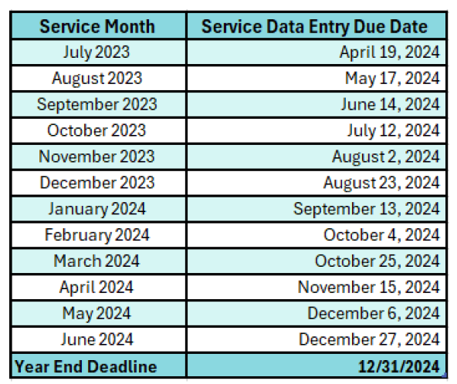

- When to indicate “Yes” or “No” using the pregnancy indicator in SmartCare.

SC requires users to indicate if the client is pregnant or not pregnant by selecting “Y” or “N’ in the Pregnancy Indicator section of the service entry screen.

When to indicate “Y” in the Pregnancy Indicator section:

- When you are made aware the client is pregnant or postpartum (typically during the intake process). Postpartum includes the 12-month postpartum period which begins on the day following the last day of the pregnancy and will end on the last day of the month in which the 365th day occurs.
- Clients in an SUD Perinatal program must be pregnant and should have “Y’ indicated.

When to indicate “N” in the Pregnancy Indicator section:

- When the client is not pregnant or postpartum
- When the client has Minor Consent Medi-Cal Eligibility and does not wish to disclose their pregnancy status
- When the client does not wish to disclose their pregnancy status and they have Fullscope Medi-Cal. This means they do not have restricted Medi-Cal benefits for emergency or pregnancy related services.

Note: Clients with restricted Medi-Cal benefits for emergency or pregnancy related services are only eligible for Medi-Cal coverage if the services meet the emergency criteria or the client is pregnant/postpartum.

If the client meets one or both criteria the Emergency and/or Pregnancy indicator on the service must be marked “Y’” and will be eligible for Medi-Cal reimbursement.

If the client does not meet one or both criteria, the Emergency and/or Pregnancy indicator on the service must be marked “N’” and will not be eligible for Medi-Cal reimbursement. Services will be denied by Medi-Cal.

